“DISPATCH TO DISCHARGE”
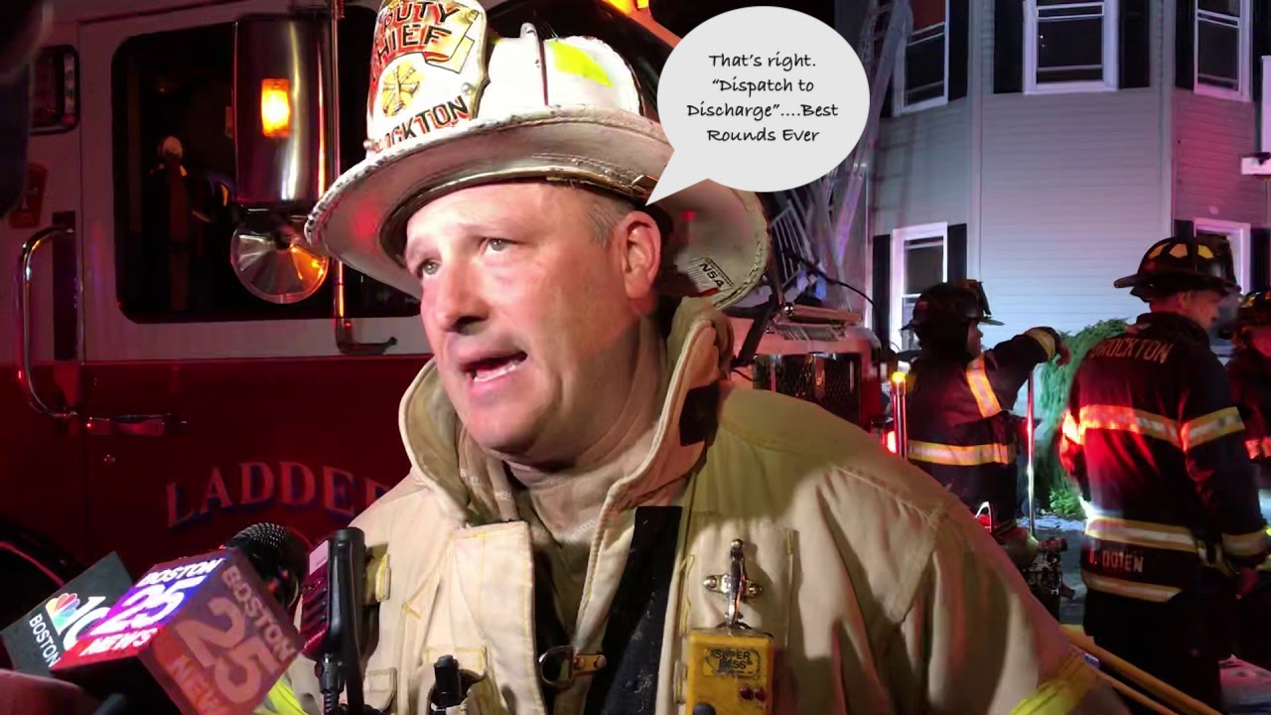

TUESDAY APRIL 30, 2024.
9 AM TO 11 AM
Topic: DISPATCH TO DISCHARGE
https://us06web.zoom.us/webinar/register/WN_oile_dACTXaEfk43hE_K5g
After registering, you will receive a confirmation email containing information about joining the webinar.

SEE NEXT PAGE FOR INSTRUCTIONS

WEBINAR ROUNDS INSTRUCTIONS
Information will be posted at www.brocktonems.com. Notices will also be sent to those on the email list.
- Register for the Webinar Rounds by clicking on the “invite” link.
- You will receive a notification that registration has been accepted along with the link to the webinar.
- Join the webinar at the scheduled time by clicking on the link at the scheduled time.

RECEIVING CME.
- The roster will be submitted by collating the names & license numbers from the registration list. This will be posted on www.brocktonems.com and sent out to those who attended by email.
- THE SURVEY MUST BE COMPLETED
- Your time on the webinar is recorded and you must stay on the webinar for the whole rounds in order to receive credit.
- A certificate will be sent to your email after confirming you were present for the rounds.
- YOU MUST LOG INTO THE WEBINAR ON YOUR OWN DEVICE. OTHERWISE, THERE IS NO PROOF OF YOUR PARTICIPATION.
- AND WE ARE DONE!

